Names ____________________________________________________________________________________Date____________________ Block ________________

**ELECTROMAGNET AND SIMPLE MOTOR**

**Electromagnets**

* By the right hand rule, a coil of current-carrying wire will create a magnetic field.

The strength of the magnetic field is based on 3 things:

* The amount of current in the wire
  + the more current, the stronger the magnetic field
* The number of turns in the coil
  + the more turns, the stronger the magnetic field.
* The material in the coil.
  + Having a magnetic material such as iron or steel as the core of the coil works to magnify the effects of the coil, thus creating a stronger magnetic field.
  + Having nothing in the coil will still produce a magnetic field, though it will be very weak.

**Building an Electromagnet**

The electromagnet is one of the most common electrical devices in use. They can be found in stereo speakers, headphones, DVD players, video recorders, wind turbines, and anything with an electric motor. The electromagnet is a great example of how electricity and magnetism are related. It also shows how this relation can convert electrical energy into mechanical energy.

**Materials**

* 3V Power Supply
* Steel nail
* Several paper clips
* Compass
* 2-3 feet of wire, insulated with exposed ends

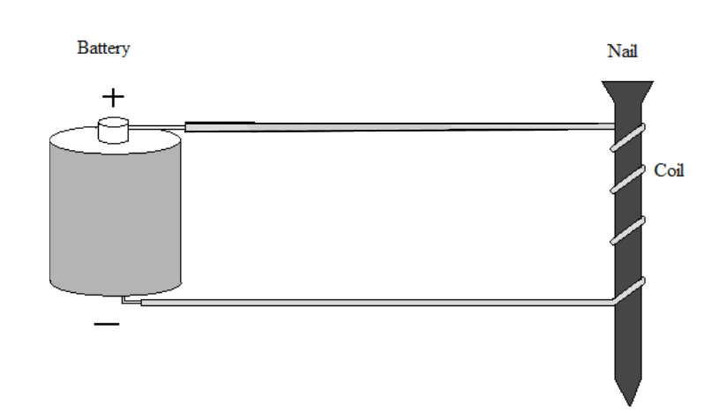

**Procedure:**

1. Make an electromagnet like the one shown in the figure above
2. Begin by wrapping your wire around your nail **10 times**.
3. Turn on your electromagnet by attaching the ends of the wire to the 3V Power Supply.
   1. **How many paper clips can you lift with the nail? _________________**
4. Turn off your electromagnet.
5. Now try wrapping your wire around the nail as many times as possible, while still leaving room to connect it to the Power Supply. Count as you go!
   1. **How many turns were you able to get? ________________**
6. Turn on the electromagnet and try to lift the paperclips.
   1. **How many paperclips can you lift now? _________________**
7. Turn off the electromagnet.
8. Using the right hand rule, predict which end of your nail is the North Pole. >?
   1. **The North Pole is the** *( point , head*  ) **of the nail.** (circle one)
9. Turn on your electromagnet and bring a compass near the ***point*** of the nail.
   1. **Is the *point* a North or South Pole? ___________________**
10. Turn off your electromagnet and switch your electromagnet around, so the electric current will flow in the opposite direction.
11. Turn on your electromagnet and again bring the compass near the ***point*** of the nail.
    1. **Is the *point* North or South now? ___________________**

**Analysis:**

1. Based on what you saw in the above experiment, list things that you think could affect the strength of your electromagnet and tell *how* they would affect the strength.

**The Electric Motor**

* By utilizing electromagnets that rotate, an electric motor or generator can be built.

An electric motor converts electromagnetic energy into mechanical energy.

* It takes electric current in a series of specially wound coils to create North and South magnetic poles that spin in a circle.
* These poles pull along magnets on a rotor, which then spins.

**Building a Simple Electric Motor**

The electric motor is an important device because it converts electromagnet energy into mechanical energy. They can be found in DVD drives, microwave ovens, blenders, power tools, vehicles, and toys. The electric motor works by creating electromagnets and then using them to push or pull other magnets, causing motion!

**Materials:**

|  |  |  |
| --- | --- | --- |
| 6V Power Supply  Plastic/Wooden Rod  3 Feet of coated wire | 2 Magnets  Permanent Marker  Sandpaper | Clear Plastic Cup  2 Large Paper Clips  Large Rubber Band |

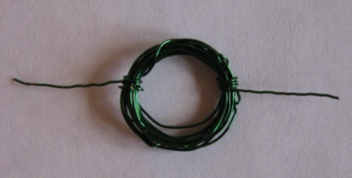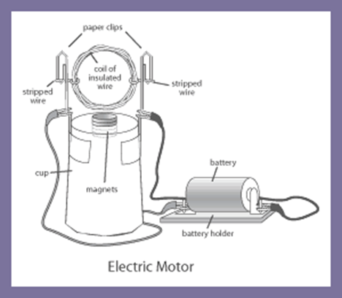

**Procedure:**

* Coat **one** side of *only* **one** of the wire tails with permanent marker (hold the coil perpendicular to the desk while you do this so that the mark is in the correct position on the tail).
* Set aside your coil.
* Take the plastic cup and place one magnet on the inside bottom and the other on the outside bottom of the cup (they should hold each other in place). **BE VERY CAREFUL!**  The magnets you are using are very strong and will shatter themselves if you allow them to snap together too forcefully.
* Wrap the rubber bands around the bottom edge of the cup
* Bend the paperclips so that they can be placed between the cup and the rubber bands and create a cradle for the wire coil to spin in.
* Place the coil in the cradle and spin it to make sure it can spin freely and is placed directly above the magnets. Make any necessary adjustments.
* Connect red alligator clip to the left paperclip and the black alligator clip to the right paper clip. Make sure they are above the rubber bands!
* Give the coil a gentle spin. If the coil does not continue to spin on its own, make any necessary adjustments until it does continue to spin.

**Analysis:**

1. Based on what you saw in the above experiment, list at least 2 things that you think could affect the speed of your motor, and how they would affect the speed (speed it up or slow it down?).
2. Describe a way you could reverse the direction of the spin of your motor.
3. Using your recently gained knowledge of electric motors, hypothesize how you think an electric generator works.